Friend Connections
-oOo-

1. New friends added to your network

Close x
Name: Bill Gates
University/College: Harvard
Major: Computer Science
Level: 4th Year
Award: Honor list 2008
Friends: 10 mutual friends
Interest: Programming, find new friend

Pic1
Add as friend
Send a message
Review his friends
Pic1

Depend on whether the user is male or female then we adjust “his/her” according on the “Review his/her friends” features.

2. Add as friend
Once user clicks on “Add as friend”, a request notes send to that user and wait for him/her to approve, once it approved then the friends adding is done.

3. Send a message
Subject
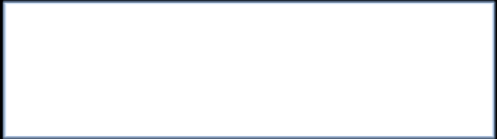

Send to Bill Gate

“Send to” is a fixed command while “Bill Gate” is changeable according to whom its person that the user intends to send. For example, if Mr. A wanted to send message to Mr. B then send command should look like “Send to B”.

4. Review his friends
Review his/her friend is depended on whether the user being review is male or female, if male then the message is “Review his friends” while if female then the message is “Review her friends”.
Once user clicks on the “Review his/her friends” then just take user to “his/her” ‘s friends section.

